

User Manual

THE HIBERNIA-SINO TRAVEL INSURANCE COMPANY POLICY MANAGEMENT SYSTEM



dEVELOPED by group 15: fifteen_go

GROUP MEMBERS: Dong Yuehui, Zhang Jingyuan, Zhang Lei,

Zhang Tianhui, Zhao Wenqi, Zhen Ziyang

**Table of contents**

1. Introduction 2

1.1 Intentions of this book 2

1.2 Manual description 2

2. System overview 2

2.1 System features 2

2.2 Operating environment 2

2.3 Overall functional structure of the system 3

3. User registration and login 3

4. Basic system operations 4

5. Personal information modification 5

6. Customer operations 6

6.1 Browse for a specific type of insurance 6

6.2 Policy management 6

6.3 Consultation management 7

7 Employee operations 7

7.1 System management 8

7.2 Home management 8

7.3 Insurance type management 8

7.4 Consultation management 8

7.5 Claim management 8

8 On Mobile devices 9

9 Common doubts Q&A 10

9.1 Connection problem 10

# Introduction

## Intentions of this book

This software is a web-based insurance service system that is developed according to the actual requirements of the Hibernia-Sino Travel Insurance Company. Users can operate from web pages or mobile devices, and employees of the company can use the same site to manage users' operations.

## Manual description

All data, examples and records used in this manual are for testing purposes and are not the real data of the Hibernia-Sino Travel Insurance Company.

Customer account: username: test_user

‘ password: 123456

Employee account: username: admin

‘ password: admin

# System overview

## System features

* This system is a cloud-based insurance management system, including client-side and employee-side.
* New users can register to create their own accounts, and the company can change the identities of users: customers or employees
* Users can submit multiple policies online. After the policy is approved by the employee, it can be viewed in the user's personal center.

## Operating environment

* **Server Appliance**

The main frequency of CPU is more than 1GHz, the memory is more than 1GB, and the free space of hard disk is more than 1GB.

* **Software Dependency**
  + Database Server: MySQL 5.5.57
  + Application Server: Tomcat 8.5.12
  + Web Server: Nginx 1.15.10
  + PHP Version: PHP-5.4
  + Key-value Database: Redis 5.0.3

## Overall functional structure of the system

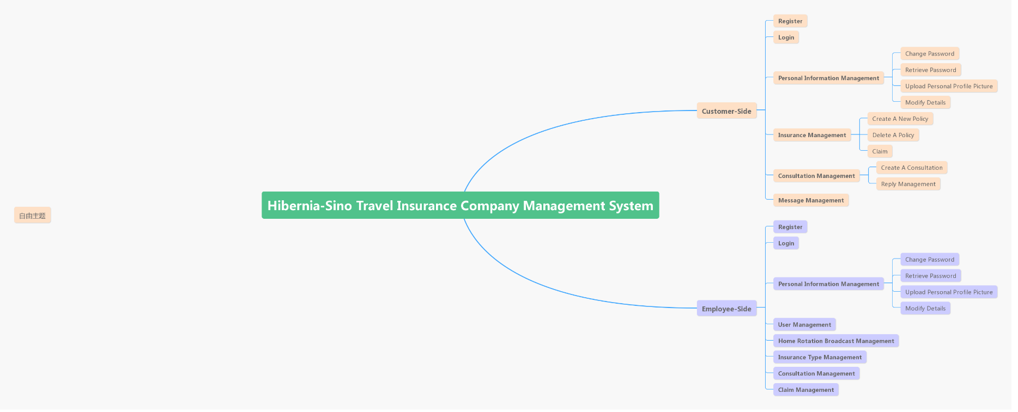

# User registration and login

* Users go to the homepage of the system through the domain name http://www.hibernia-sino.cn or the IP address http://123.207.144.103/.
* Click the “loogin” button to enter the login/register page
* New to the Hibernia-Sino Travel Insurance Company

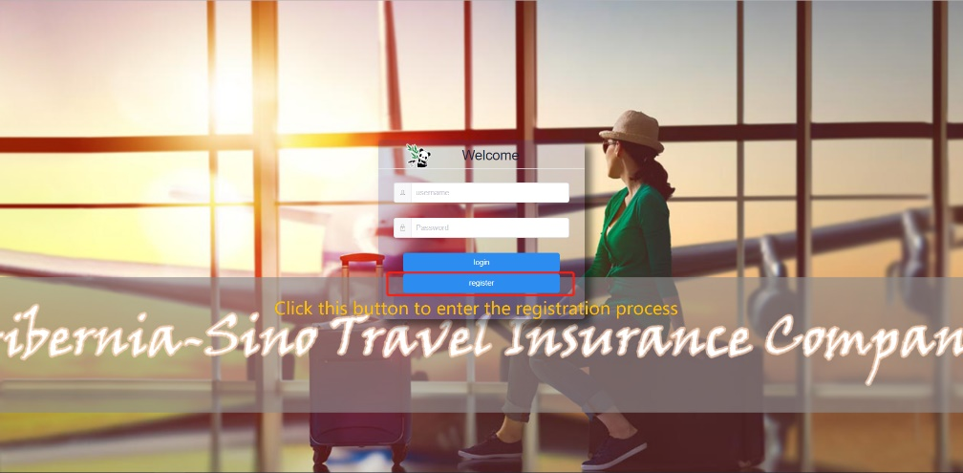

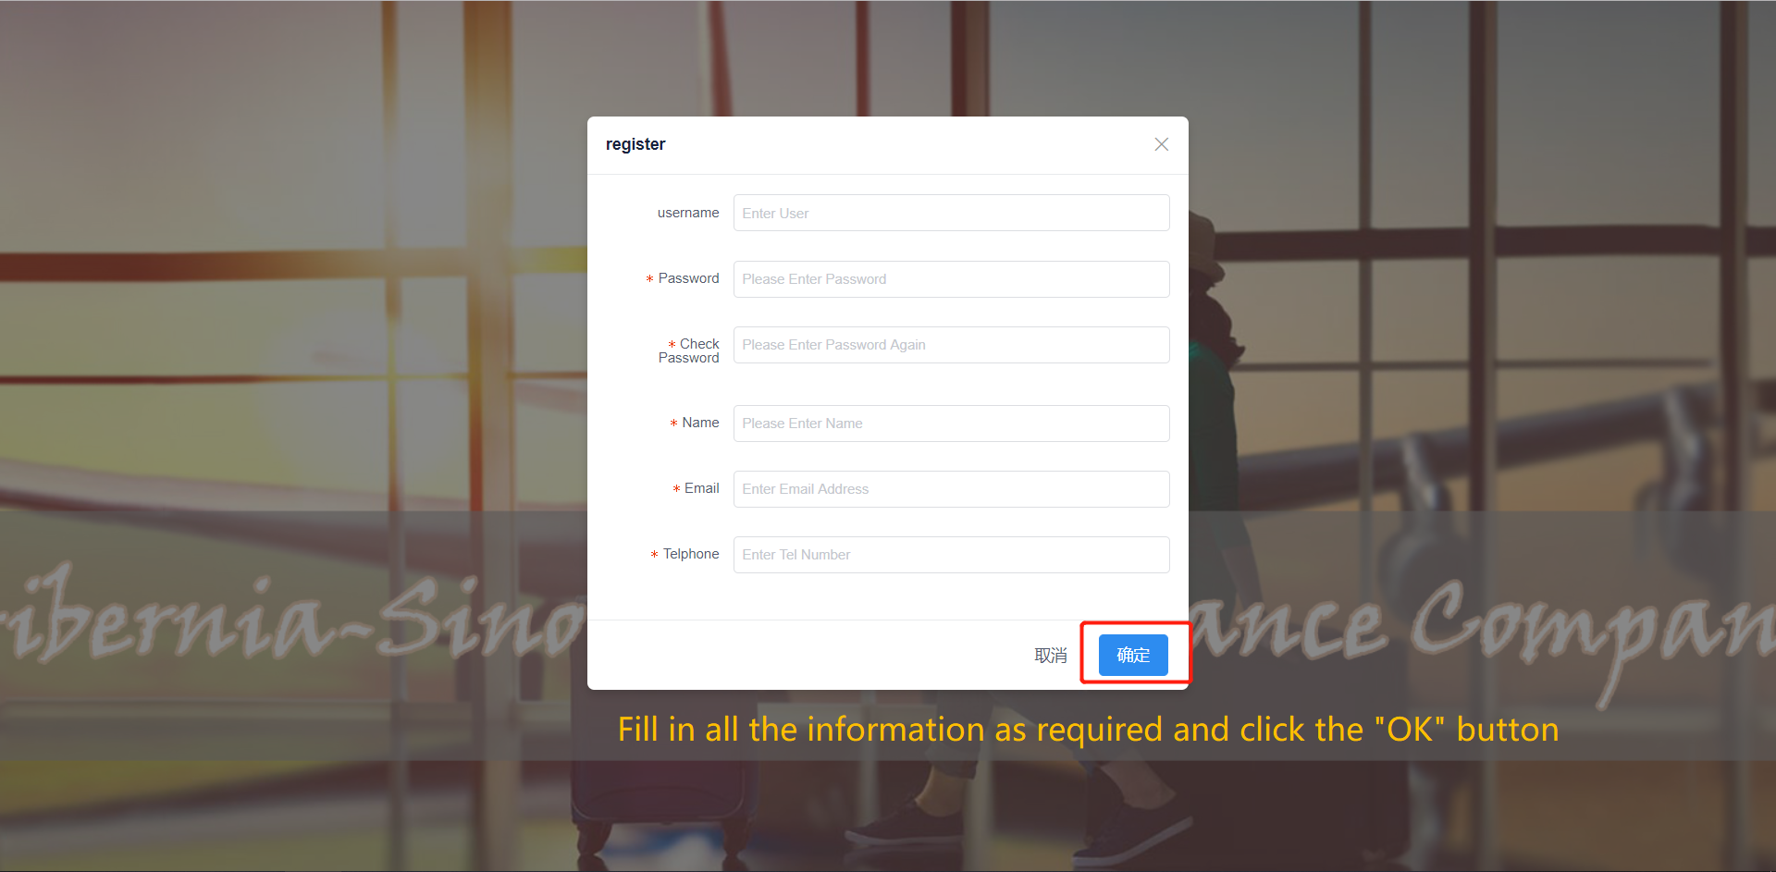

* Already have an account

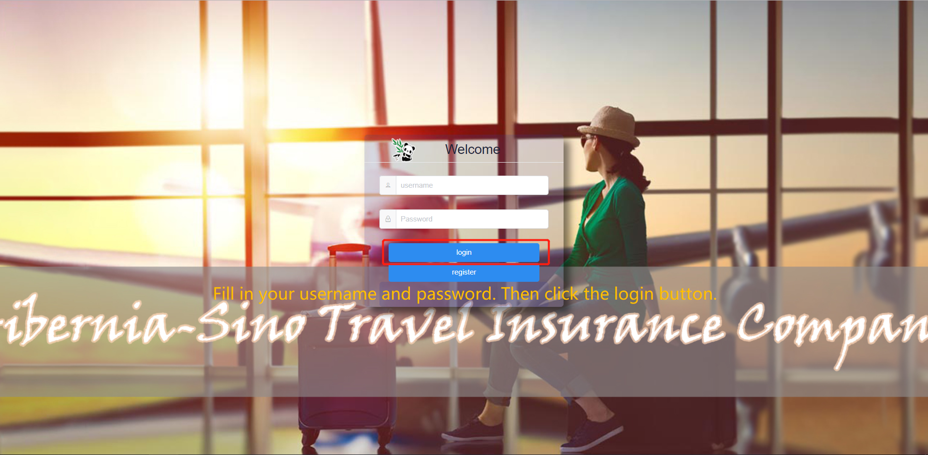

# Basic system operations

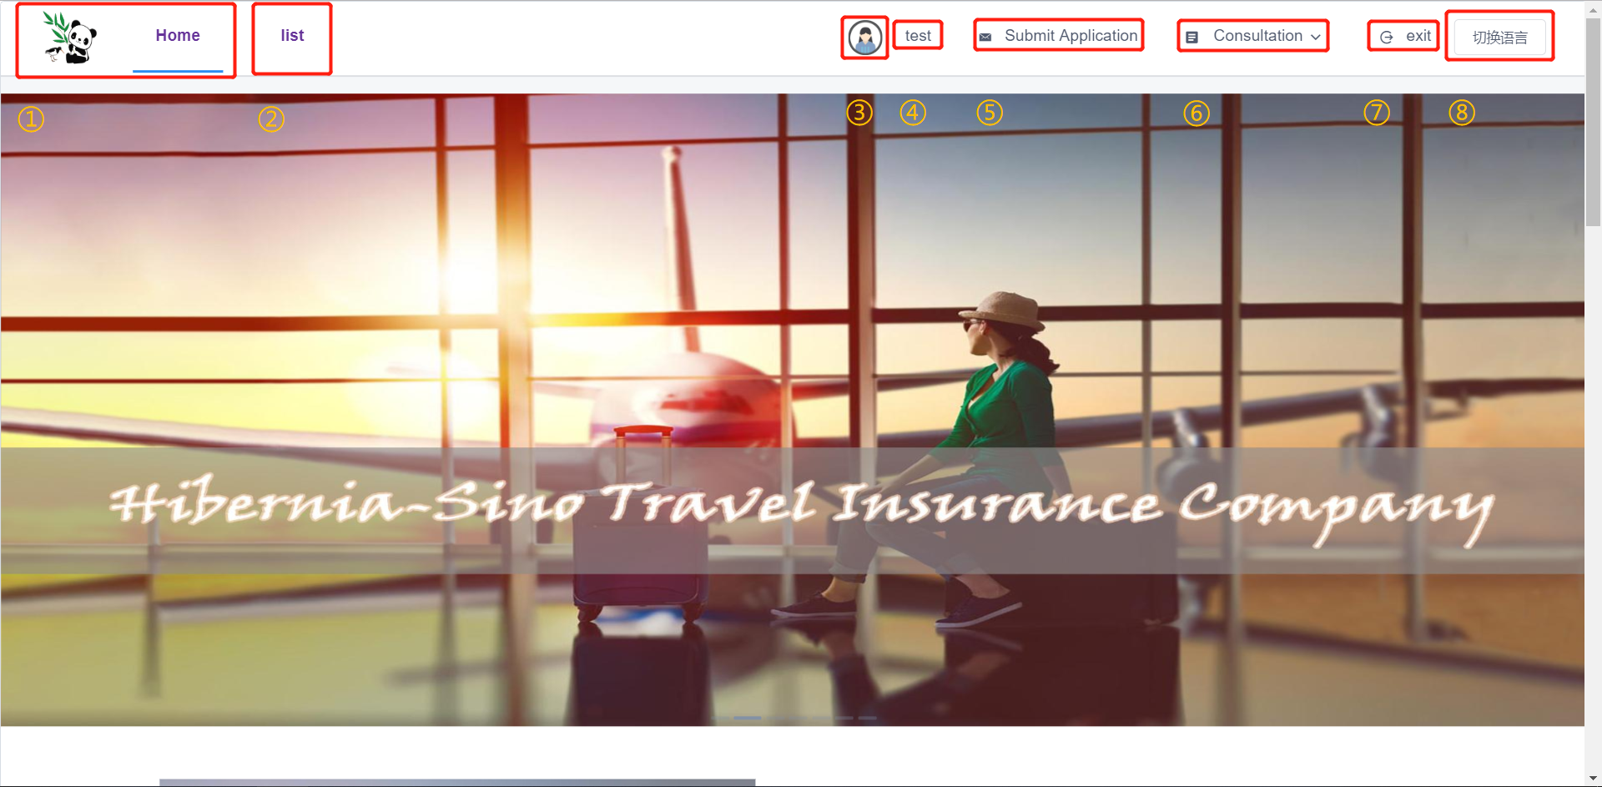

Note: Take the common **customer** page as an example.

* 1. Back to the home page
* 2. View the policy list of the current account
* 3. View the reply (message) the account received
* 4. Modify the personal information
* 5. Create a policy
* 6. Submit consultation/check the consultation reply
* 7. Exit the current account
* 8. Change system language (after login)

# Personal information modification

**Basic operations (4): Modify the personal information**

Note: Take the common **customer** page as an example.

* Text information modification

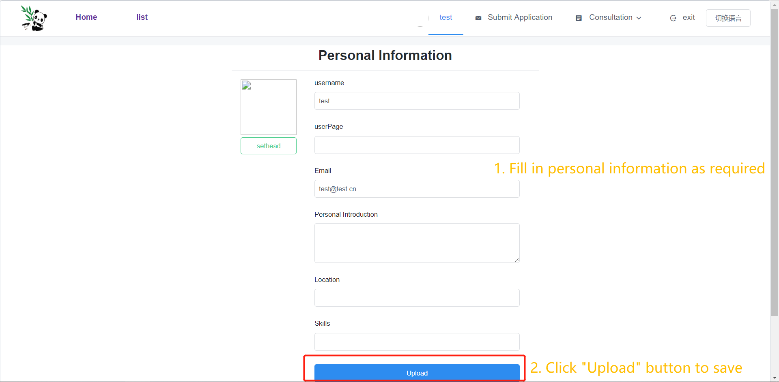

* Head portrait modification

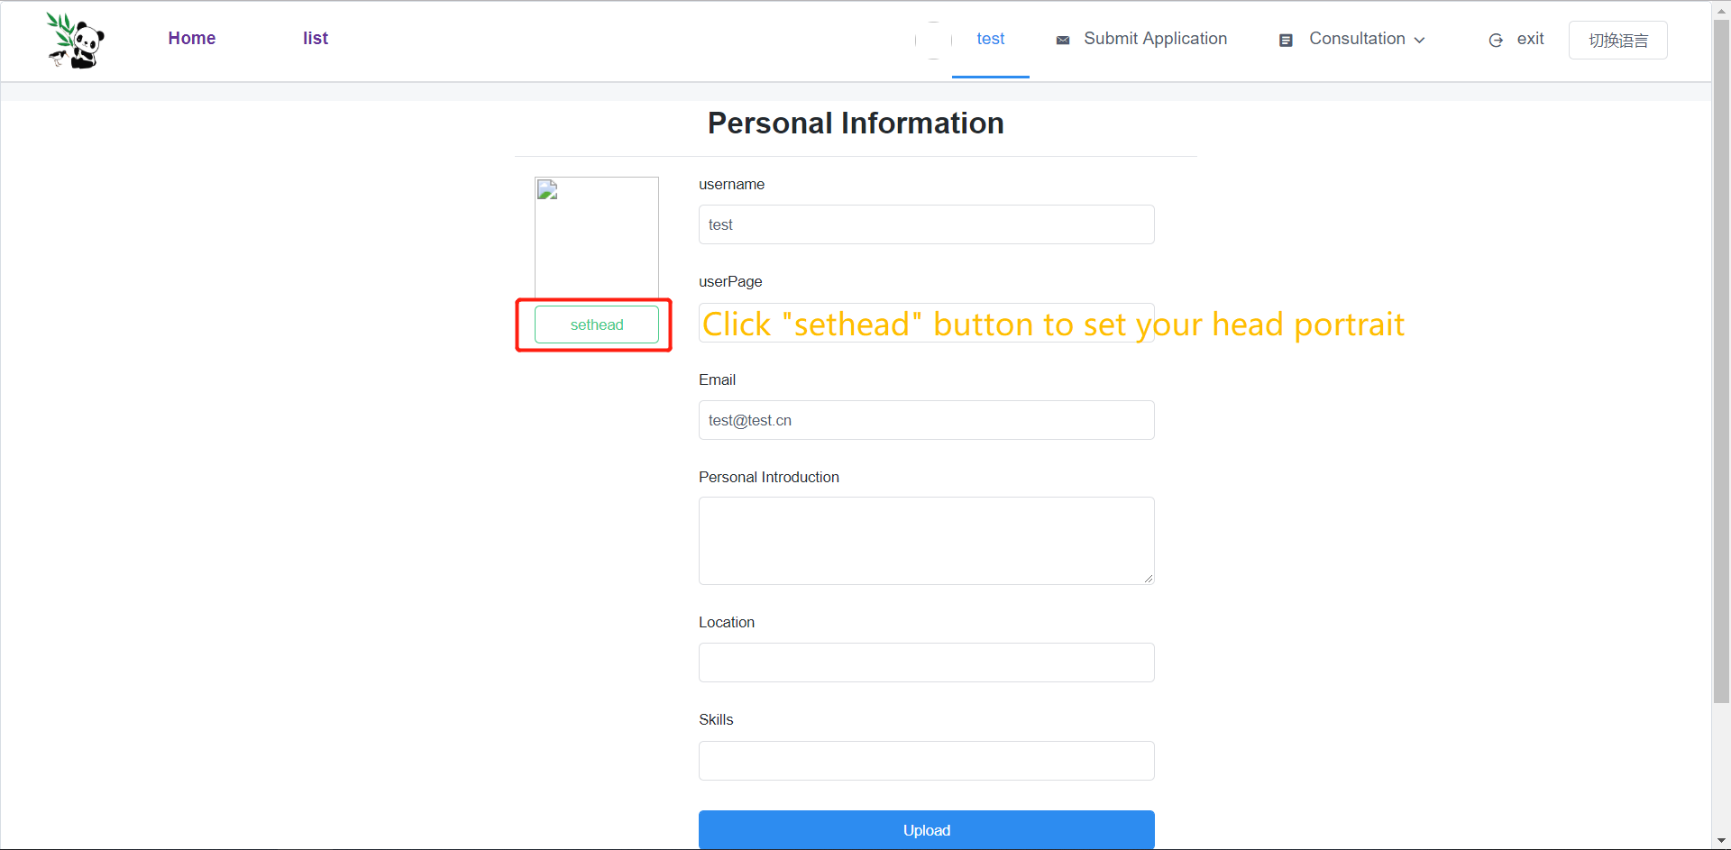

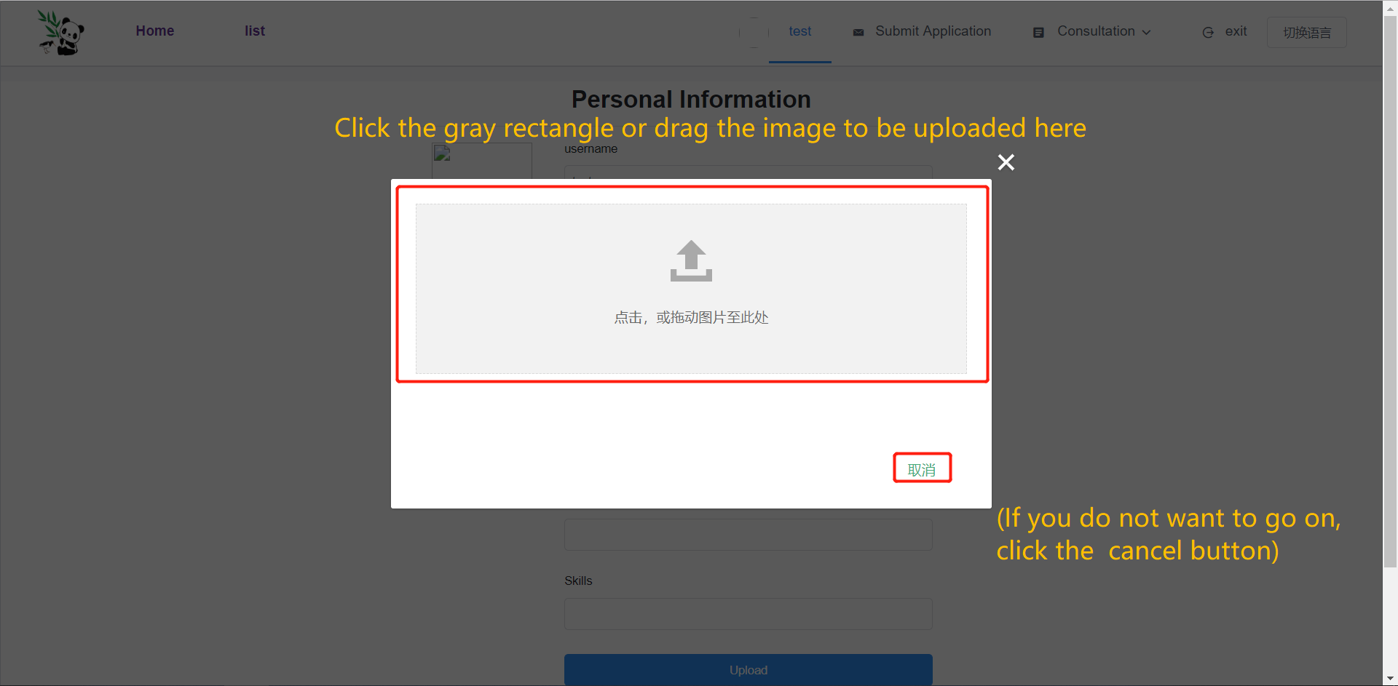

Note: There is no need to click the “Upload” button again for uploading a picture.

# Customer operations

## Browse for a specific type of insurance

There are four different types of insurance displays at the bottom of the home page. Click the picture or text to enter the details page of corresponding insurance.

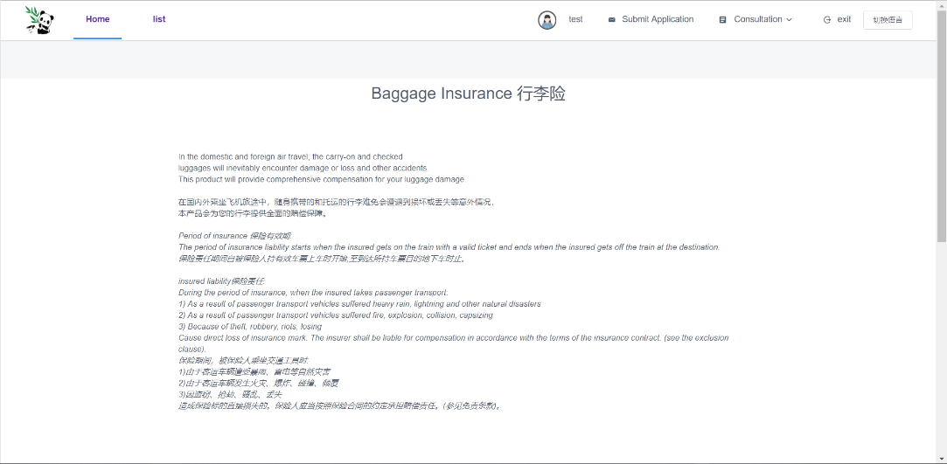

Note: There is a question area under the details section. Customers can ask questions of specific types of the company.

## Policy management

**Basic operations (5): Create a policy**

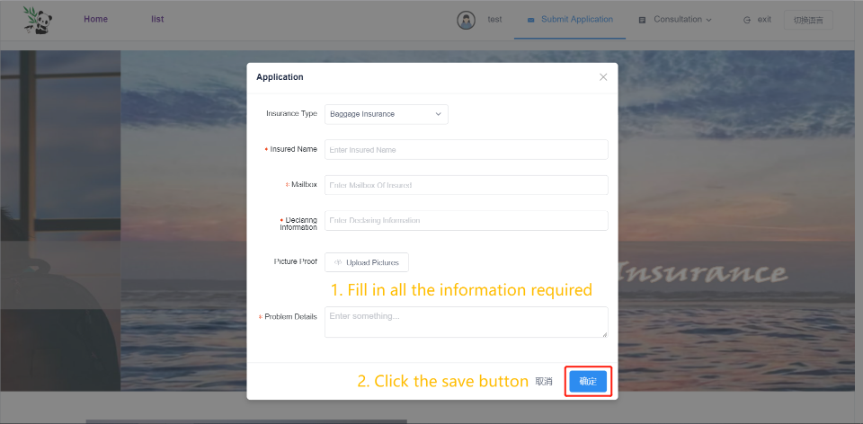

Then you could check or delete your policies by **Basic operations (2): View the policy list of the current account.**

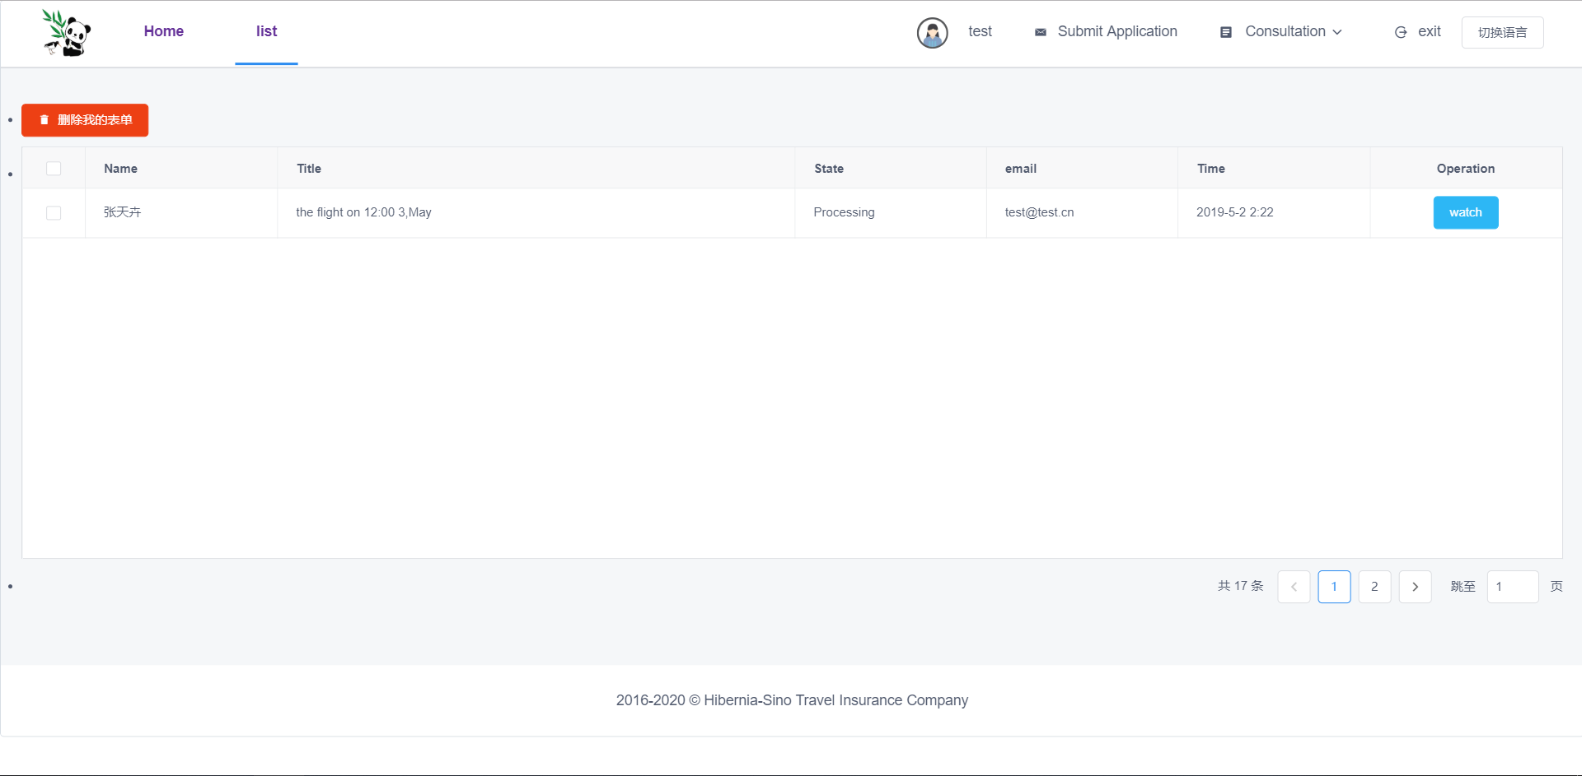

## Consultation management

**Basic operations (6): Submit consultation/check the consultation reply**

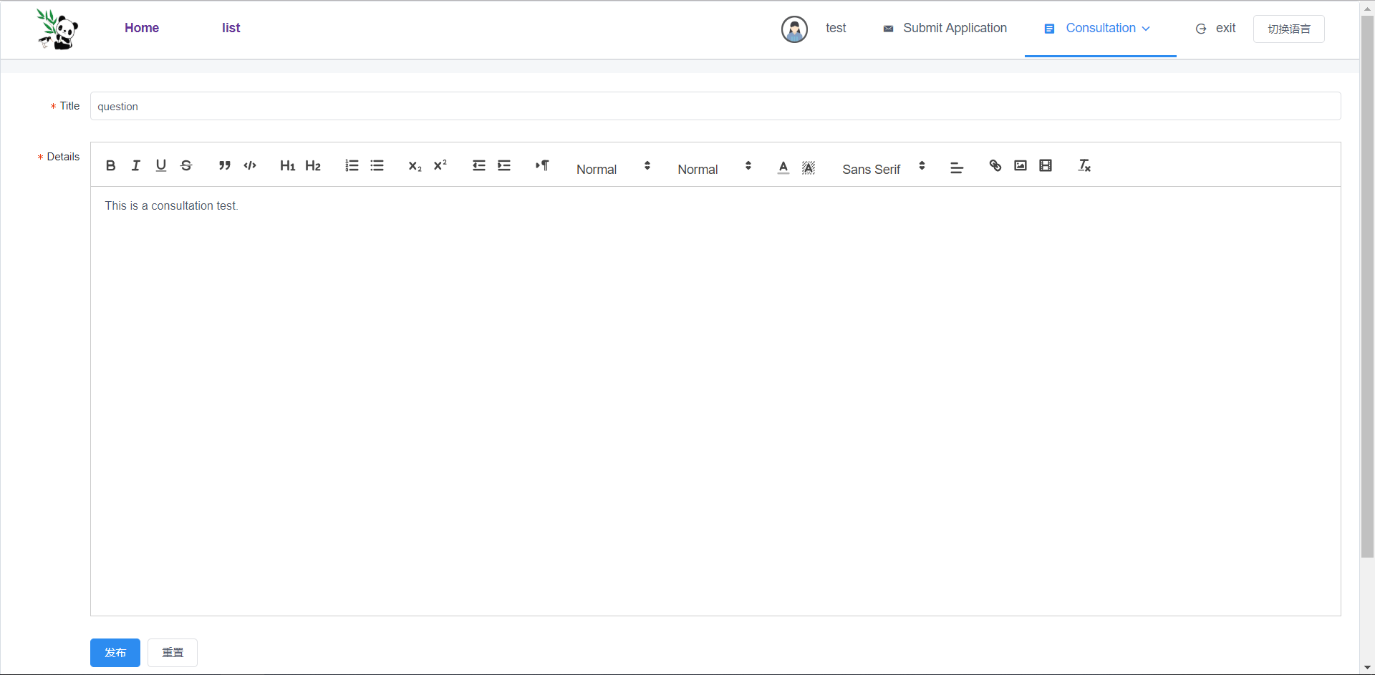

# Employee operations

**Firstly, entry the console by clicking the “console” button next to the “exit”.**

**Then you will see the console page as follow:**

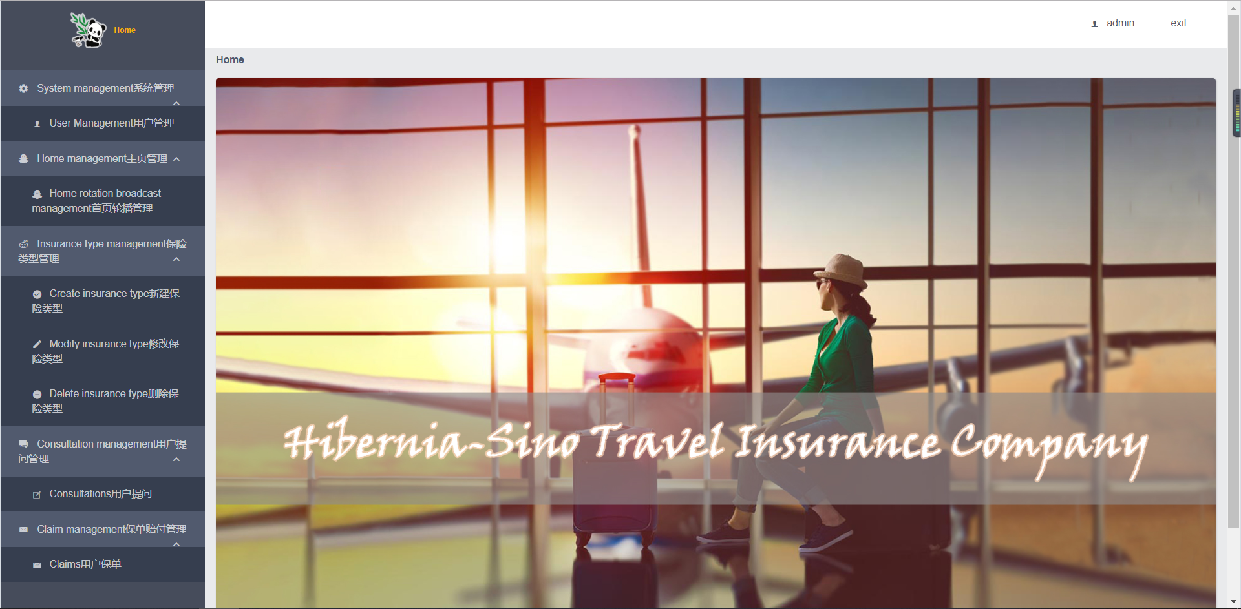

## System management

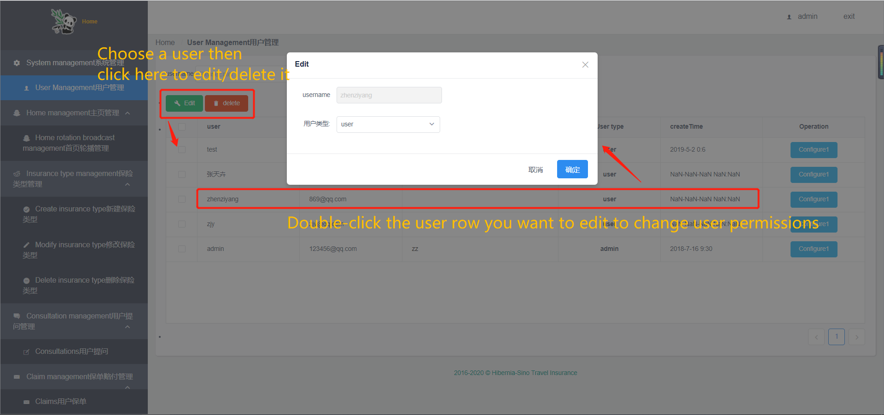

## Home management

## Insurance type management (follow the guide)

## Consultation management (follow the guide)

## Claim management

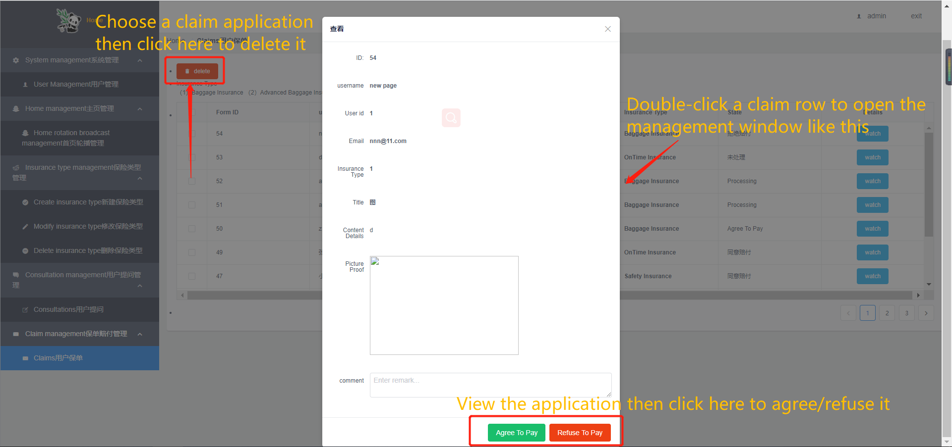

# On Mobile devices

* **Use the browser of mobile devices**

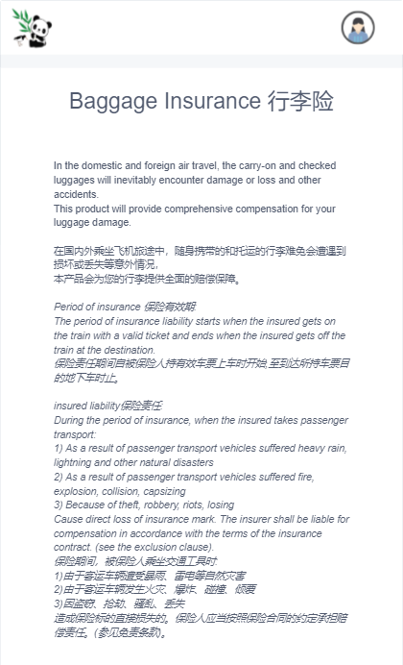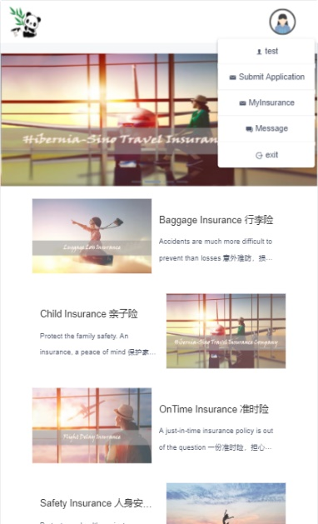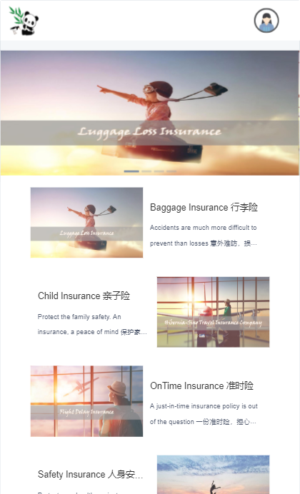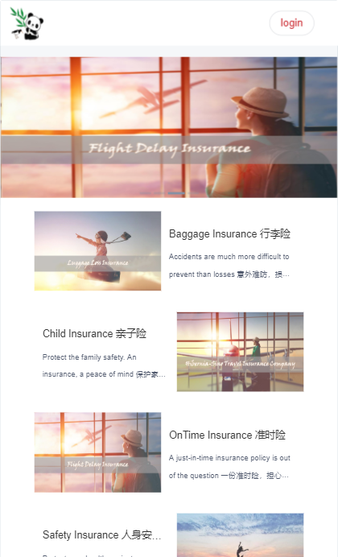

Click here to open the menu

Click here to Login/ register

Click to enter the function you need

For example, click the picture to enter the insurance details page, as shown in the figure.

* **The Android Application**

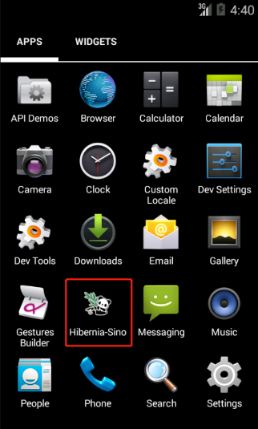

You could get the app from

(GitHub)

We adapted the web page to the mobile terminal. Operations are unaffected except for layout changes.

# Common doubts Q&A

## Connection problem

* Q: When you open the page, there is no picture and no display component.

Three "no permission" prompts pop up.

A: This is because the back end is not running correctly, please call a

technician.

* Q: When logging in with the test account, you are prompted with an error in

the user name or password.

A: This is because there is no connection to the database. Please check the

interest-server\src\main\resources\application.yml file. It should be like:

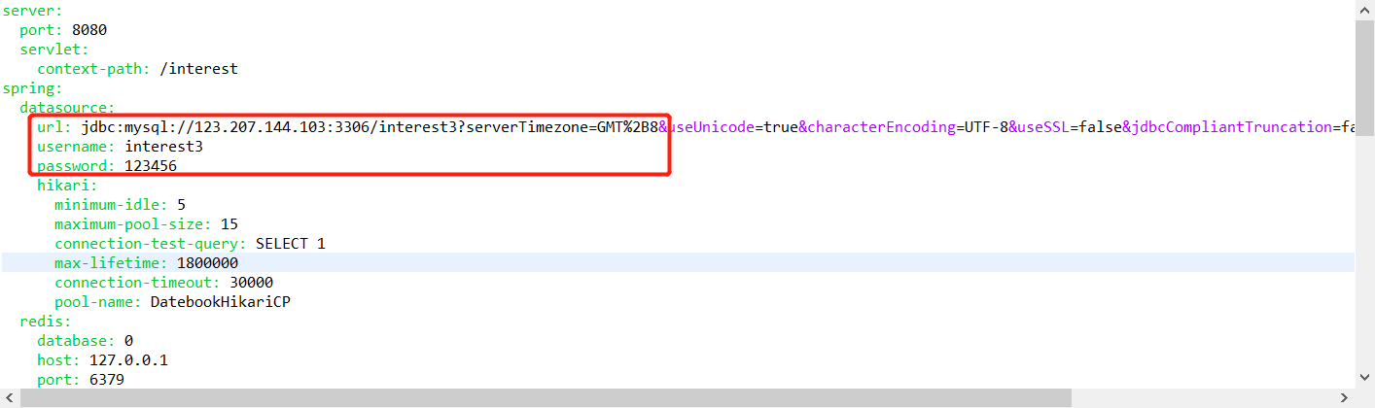

* Q: Home page picture shows loading error.

A: Make sure your image folder, interest, is unzipped to the correct path:

D:\interest\file\image